### I Now Love Making Paper Houses

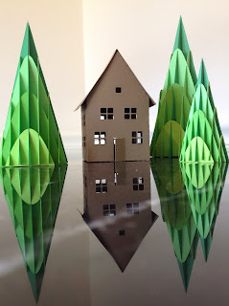

Paper House with Slice form Trees

I love making all kinds of houses. First gingerbread houses...I have made more than a hundred gingerbread houses over the course of many holidays. I even made them for a bridal shower.

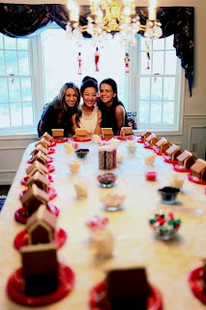

Katie's friend - Lisa's shower party

Then doll houses...

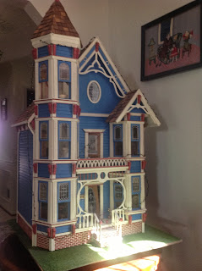

Now, I decided I need to make the houses in paper. This model is four inches tall

